**COMPUTATION AND PROBLEM SOLVING**

**Laboratory work #7: JavaScript Introduction**

Tasks 1 and 2 - in 1 html file

Task 3 - in a separate html file (links to each other, or - 0)

**Submit in DL – rename correctly, 1 zip file with 2 html files**

Part 1 Problems 1-5 - write with comments in html file

Part 1 Problems 6-7, Part 2 – create the button and write functions/loops with js into the html file

**PART I**

1. Open The Chrome Internet browser, press F12 to open the Chrome DevTools, and open the console window in Chrome DevTools by clicking on the “Console” tab
2. Practice writing strings within the console using console.log()
   1. Example: console.log(“Hello World”);
3. Use .length to get a property of the string
   1. Example: console.log("Hello World".length);
4. Write some simple mathematical operations within console.log()

Examples:

console.log(28 + 7);

console.log(123 - 23);

console.log(5 * 4);

console.log(28 / 7);

console.log(5 > 3);

console.log(“5” === 5);

console.log(“5” == 5);

* 1. What is the difference between =, ==, ===?

1. Practice writing some code that uses various mathematical methods like .round, .floor, .random, .min, .max:

Examples :

console.log(Math.round(5.8) * 6);

console.log(Math.random());

console.log(Math.floor(3.9));

console.log(Math.min(3, 12});

console.log(Math.max(3, 12));

1. Write a JavaScript command that will display:
   1. A random number between 5 and 20
   2. A random number between 15 and 100
   3. Multiply the number of characters in “Donald Trump” by the rounded sum 6.6 + 7
2. Divide the length of “1 411 890” by the floor of 3.21

**PART II**

1. Annoying-O-Matic

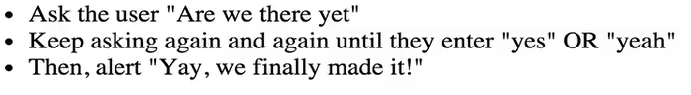

1. 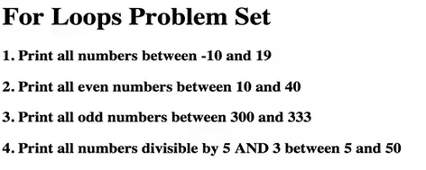
2. 